✅ Linux Basics — Section-wise Tasks + Commands

Section 1️⃣ — What is Linux? (Theory Task)

🎯 Task

Understand the difference between Linux Kernel vs Linux Operating System

Concept | Meaning
Kernel | Core part — manages memory, CPU, processes, hardware
OS | Kernel + Shell + Drivers + Utilities + Package Manager + GUI

📝 Example Analogy
Kernel = Engine
Linux OS = A complete Car

Section 2️⃣ — Linux Distributions (Theory Task)

🎯 Task

Know why different distros exist & where they are used

Distro | Package Manager | Use-case
Ubuntu | apt | Servers, Cloud, Beginners
Kali Linux | apt | Pentesting, Red Team
Rocky Linux | yum / dnf | Enterprise RHEL Alternative
Debian | apt | Stable base OS
Parrot OS | apt | Pentesting, Privacy
REMnux | apt | DFIR, Malware Analysis

📝 Key takeaway
Different UI, tools & configs → Not different OS, just different flavours.

Section 3️⃣ — Linux vs Windows (Theory + Commands Task)

Topic | Windows | Linux Command
View Processes | Task Manager | top, htop, ps aux
Manage Services | services.msc | systemctl start/stop/status
File System | C:, D:, E: | Single tree / hierarchy
Users | Local/Domain | Strict least privilege — UID/GID
Run Admin Jobs | Run as Admin | sudo <command>

Section 4️⃣ — Linux File System & Navigation

🧭 Task 1 — Explore root directory
ls /

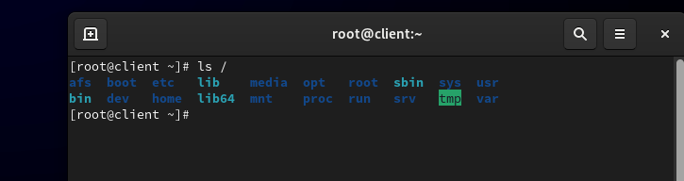

🧭 Task 2 — Move between directories

cd /home
cd /var/log
cd -
pwd # show current location

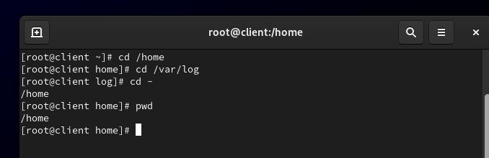🧭 Task 3 — View files & details

ls -la
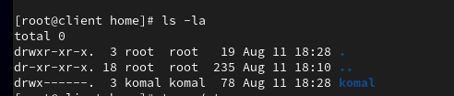
tree /etc
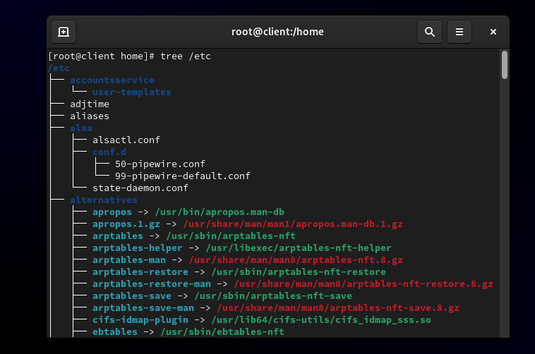

📌 Important Directories

- /home – user personal data
- /var/log – system logs
- /etc – config files
- /bin, /sbin – system binaries
- /tmp – temporary files (auto-cleared)

Section 5️⃣ — Files & Directories Operations

📌 Task 1 — Create a file
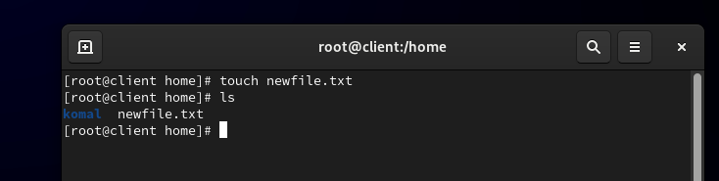

📌 Task 2 — Write/Edit a file
nano newfile.txt
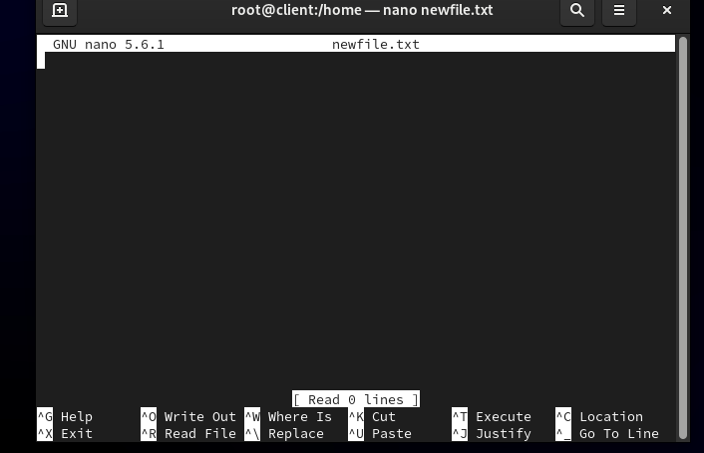
Save: Ctrl + X → Y → Enter

📌 Task 3 — View file content
cat newfile.txt
head newfile.txt
tail -f /var/log/syslog # real-time logs
less newfile.txt # scroll page-wise
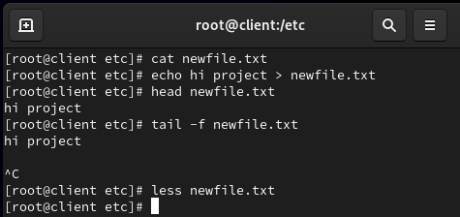

📌 Task 4 — Create/Delete Directories
mkdir test
mkdir -p parent/child # recursive
rm -r test # delete folder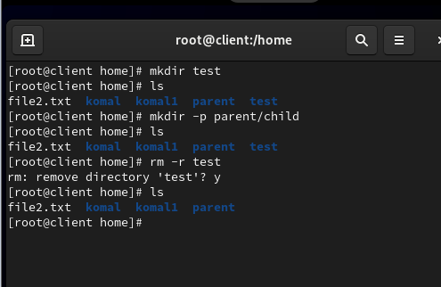
📌 Task 5 — Copy & Move files
cp file1.txt file2.txt
mv file1.txt /var/log/
rm unwanted.txt
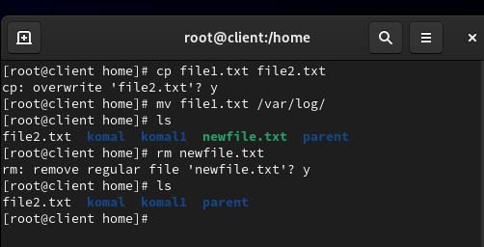

Section 6️⃣ — Users, Groups & sudo Privileges

👤 Task 1 — Identify current user & users list

whoami
cat /etc/passwd
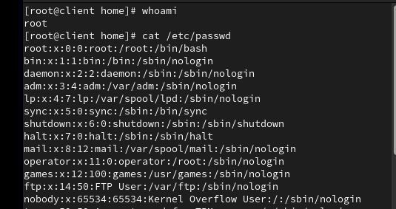

cat /etc/group
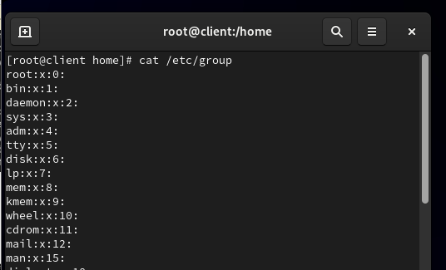

👤 Task 2 — Create a user & add to sudo group
sudo adduser john
sudo usermod -aG sudo john
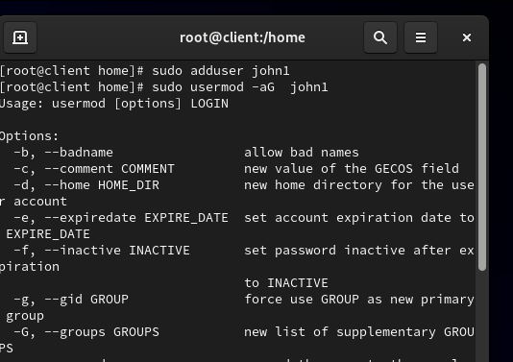

👤 Task 3 — Switch user
su - john

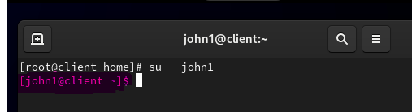

👤 Task 4 — Verify sudo access
sudo apt install nmap
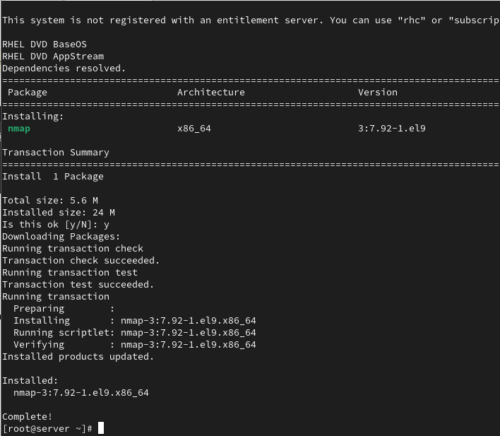

Section 7️⃣ — File Permissions & Ownership
📌 Permission Concept
r = read (4)
w = write (2)
x = execute (1)
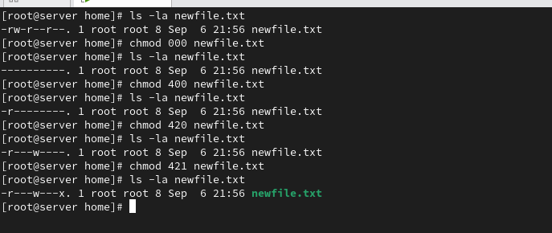
🔐 Task 1 — Check File Permissions
ls -l
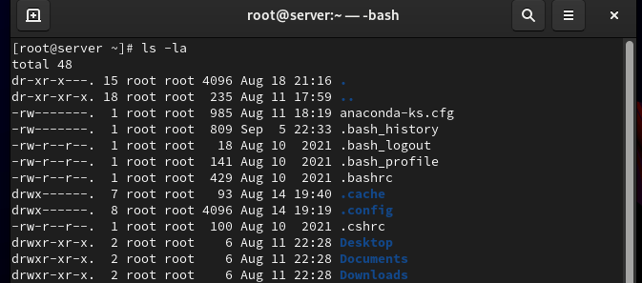

🔐 Task 2 — Change permissions
chmod 777 file.sh # rwx rwx rwx
chmod 755 file.sh # rwx r-x r-x
chmod 644 file.sh # rw- r-- r—

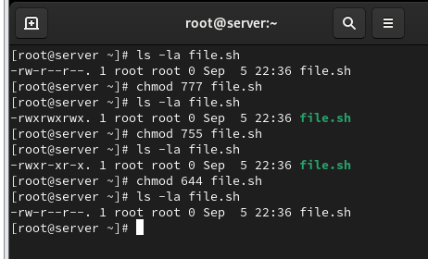

🔐 Task 3 — Change ownership
sudo chown john:john file.sh

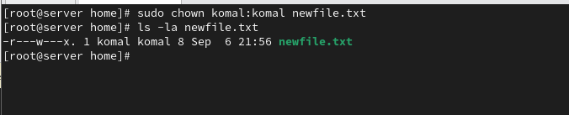

Section 8️⃣ — System Monitoring (CPU, RAM, Disk, Network)

📊 CPU & Process Monitoring

Top
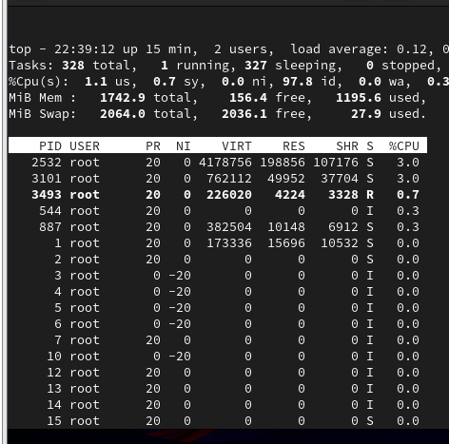
htop
ps aux

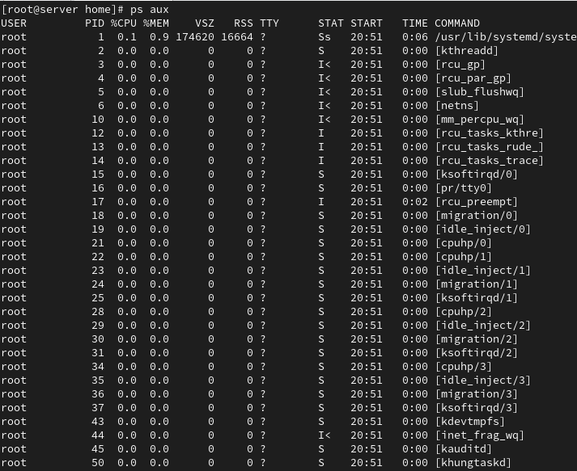
🧠 Memory Monitoring

free -h

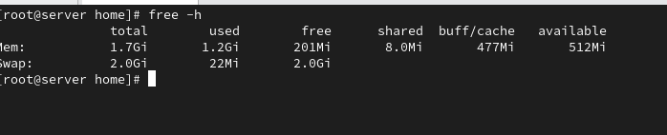

💾 Disk Usage
df -h
du -sh /var/log/*
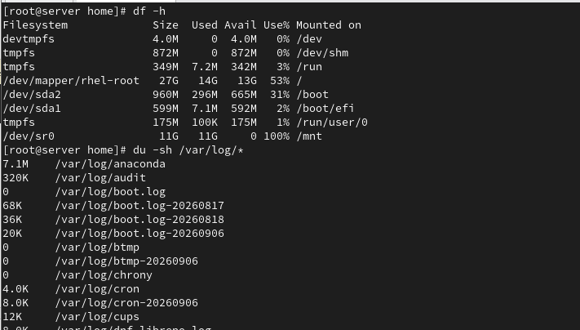

🌐 Network Monitoring
ip a
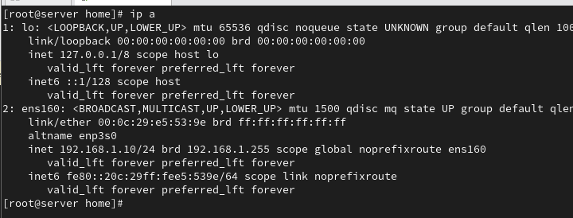

netstat -tulnp
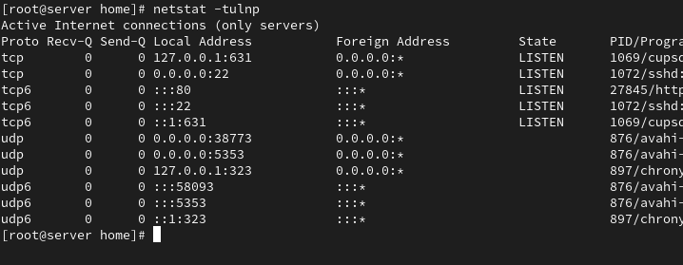
ss -tulnp # modern replacement
